22. Develop a system using UML for Online Insurance Processing System. The admin can create a category and sub-category, under which a new policy can be added. The user can view and buy the required policies. The system is managed by the Insurance Management System.

**Activity Diagram :**

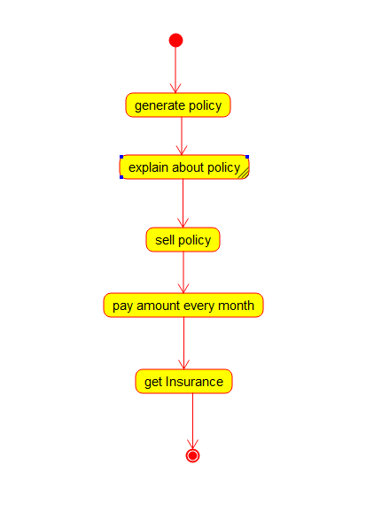

**Class Diagram** :

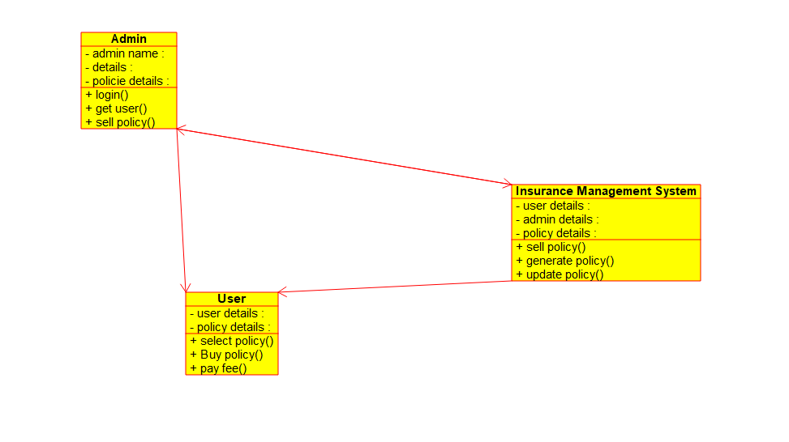

**Deployment Diagram :**

